# FUNCTIONS :-

* A function is a block of code that performs a specific task or set of tasks. It can take input, process it, and return an output.
* Functions are defined using the **‘def’** keyword in most programming languages.
* They have a name, a parameter list, and a body where the actual code is written.
* You can call a function by its name to execute the code within it.

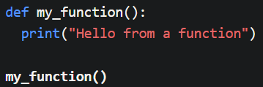

# Arguments :-

* Information can be passed into functions as arguments.
* 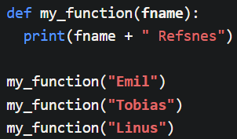Arguments are specified after the function name, inside the parentheses. You can add as many arguments as you want, just separate them with a comma.
* If you do not know how many arguments that will be passed into your function, add a **\*** before the parameter name in the function definition.
* Python also accepts function recursion, which means a defined function can call itself.
* 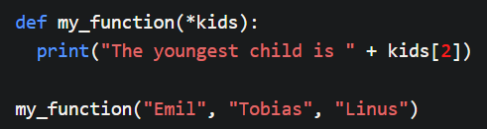This way the function will receive a tuple of arguments, and can access the items accordingly.

# Lambda :-

* A lambda function is a small anonymous function. It can take any number of arguments, but can only have one expression.
* Syntax :
* 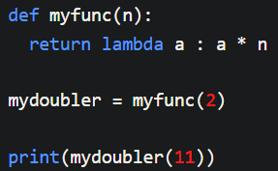The power of lambda is better shown when you use them as an anonymous function inside another function.

# MODULES :-

* A file containing a set of functions you want to include in your application.
* Write a code of any function, save it in your folder with some name like filename.py
* You can use this module in new python files with **’import’** keyword, like ***‘import filename’***.
* Also you can use **‘as’** keyword to rename your module.

**# PRACTICE QUESTIONS :-**

1. Write a Python function that takes two numbers as input and returns their sum.
2. Define a function that calculates the factorial of a given positive integer using a loop.
3. Create a Python module called ***math_operations*** with functions for addition, subtraction, multiplication, and division. Import this module and use it to perform these operations.
4. Write a Python function that takes a list as a parameter and returns the maximum value in the list.
5. Define a function that generates a Fibonacci sequence of a given length using recursion.
6. Create a Python module named **utils** that contains a function to check if a number is prime or not. Import this module and use the function to determine if a given number is prime.
7. Write a function that takes a string as input and returns the string reversed.